
PROJECT REPORT
GEOMETRIC CALCULATOR

:
:
:
:
December 13, 2023

NAME MUHAMMAD SAGHEER
CMS 023-23-0376
SECTION: “C”
Instructor Sir Nadeem

Introduction:
The Geometric Calculator is a C++ program designed to calculate various properties of 2D and 3D shapes. The program provides a user-friendly interface where users can choose the type of shape and the specific calculation they want to perform.

Features:
2D Shapes:
The program supports calculations for 2D shapes such as Circle, Square, Triangle, Rectangle, Parallelogram, Trapezoid, and Hexagon.

3D Shapes:
Users can also perform calculations for 3D shapes including Sphere, Cube, Cylinder, Cone, Cuboid, Pyramid, and Prism.

Multiple Calculations:
For each shape, users can choose between different calculations, such as area, perimeter, surface area, and volume.
User Interaction:
The program engages users through a menu-driven interface, allowing them to make choices based on their specific needs.

Implementation:
The program is implemented in C++ and organized into functions for each type of shape and calculation.

A clear and user-friendly interface is presented to guide users through the selection process.

How to Use:
1. Run the program.
2. Choose the dimension (2D or 3D).
3. Select the specific shape you want to calculate properties for.
4. Choose the calculation you want to perform.
5. Enter the required input values.
6. View the calculated result.
7. Decide whether to continue or exit the program.

Certainly! Let's define each step in the program:

- Welcome Message:
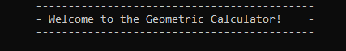

This is the introductory message that welcomes the user to the geometric calculator.
2. Choose the Dimension:
Choose the type of shapes to calculate:
- 2D 2.3D
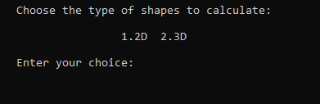
Enter your choice: 1
The user is prompted to choose between 2D and 3D shapes. They enter their choice (in this case, 1 for 2D shapes).

- Select 2D Shape:
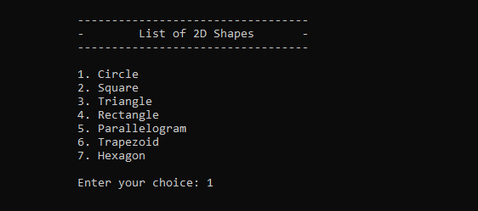

Enter your choice: 1
The user is presented with a list of 2D shapes and asked to choose one.
Here, they enter 1 for a circle.
4. Calculate Circle Area:
Enter the radius of the circle: 5
The area of the circle is: 78.5398

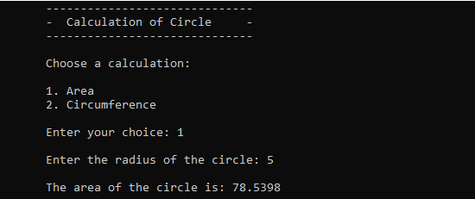

The program prompts the user to enter the radius of the circle and calculates its area.

5. Continue or Exit:
Do you want to continue? (y/n): y
The program asks if the user wants to continue. If the answer is 'y', the program continues; otherwise, it exits.

6. Choose Dimension Again:
-------------------------------------------
Choose the type of shapes to calculate:
- 2D 2.3D
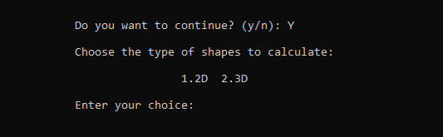
Enter your choice: 2
If the user chooses to continue and selects 2 for 3D shapes, the process repeats for 3D shapes.
7. Select 3D Shape:
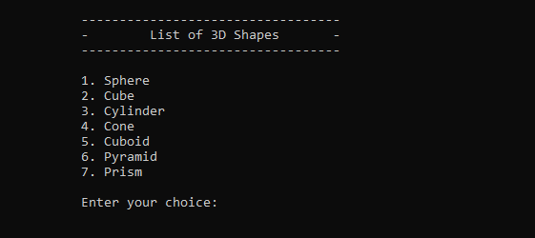
The user is presented with a list of 3D shapes to choose from.

And so on. The program guides the user through shape selection, calculation input, and displays the results accordingly.

Conclusion:
The Geometric Calculator project provides a versatile tool for calculating properties of various 2D and 3D shapes. Its user-friendly interface and modular design make it accessible for users to perform calculations based on their specific requirements. The project demonstrates effective use of C++ programming concepts and provides a useful utility for anyone needing quick geometric calculations.

